Supplementary Information for
Decoding the association between urban streetscape skeletons and urban activities: Experiments in Beijing using Dazhong Dianping data
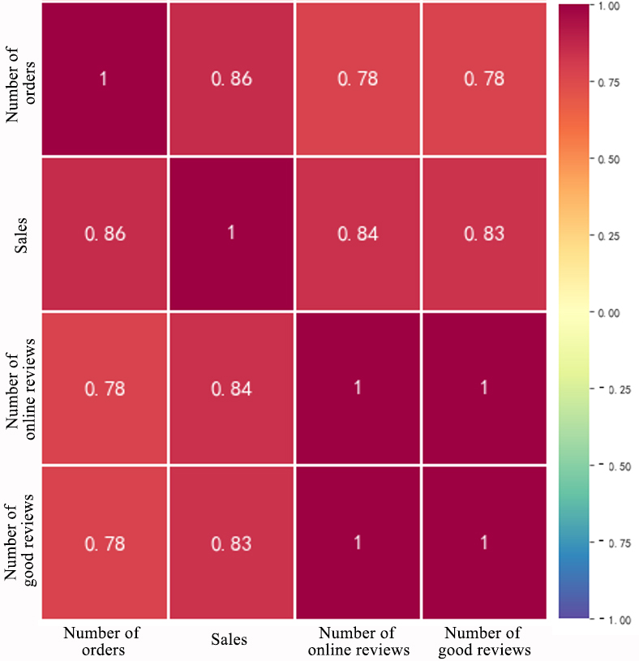
Figure S1. Correlation matrix between the number of orders, sales, number of online reviews, and the number of good reviews (Data source: collaborative research with Meituan & Dianping).
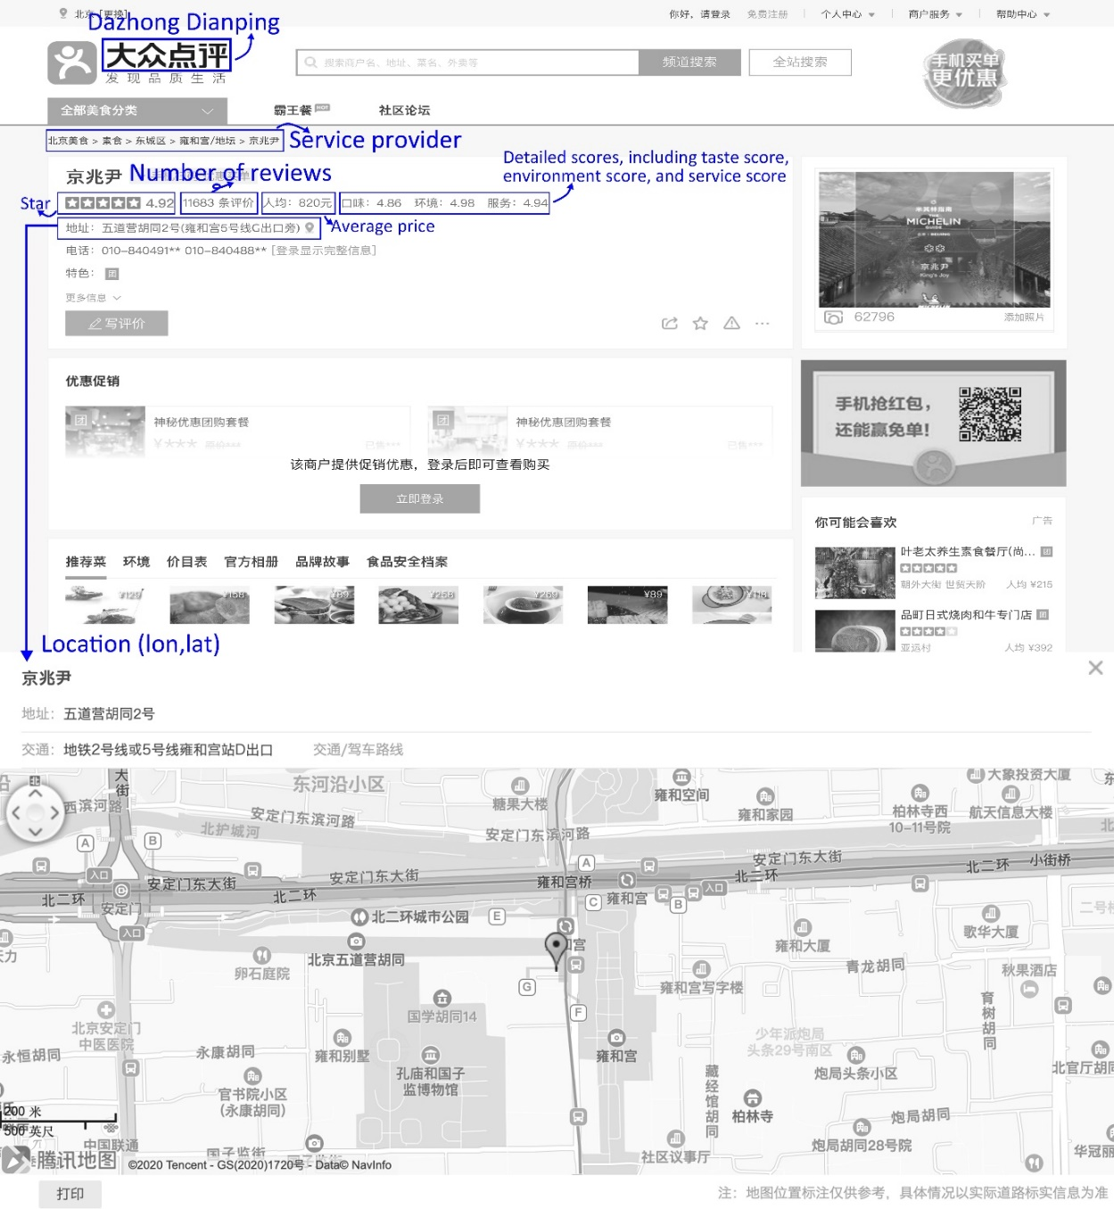
Figure S2. A detailed page of Dazhong Dianping and attributes used in this research.

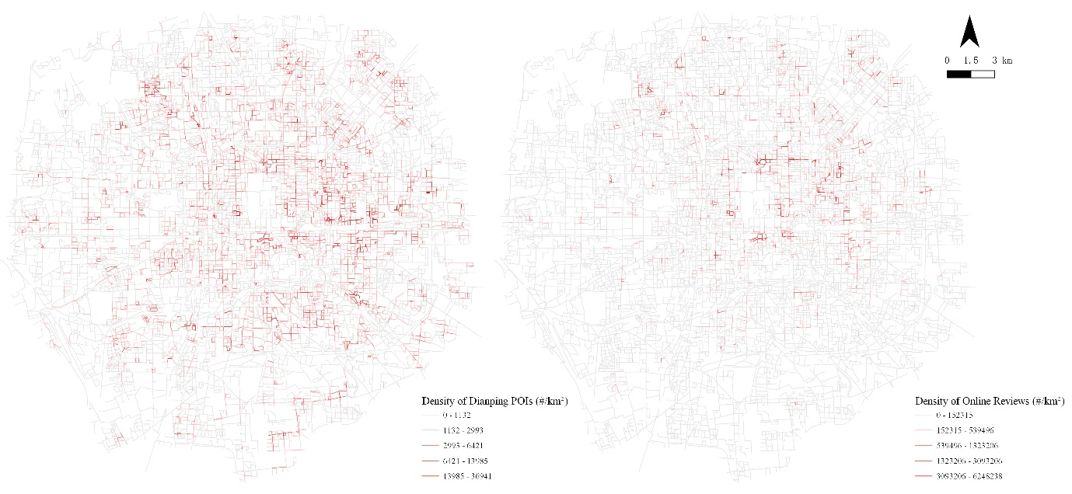
Figure S3. Spatial visualization of the density of Dianping POIs (left) and online reviews (right).

Note 1. Methods to extract street view pictures.
For all the processed streets within the fifth ring road area, we divided each street segment into vertices with 50 meters. The corresponding vertex coordinates were input into the place ID retrieval API and the main API for downloading the street view pictures of four different horizontal angles, including the front, back, left, and right sides. Therefore, for each street, several vertices spaced 50 meters apart were distributed along the street, providing us with 4-direction scenes for each vertex that could represent the overall spatial elements of a specific street.
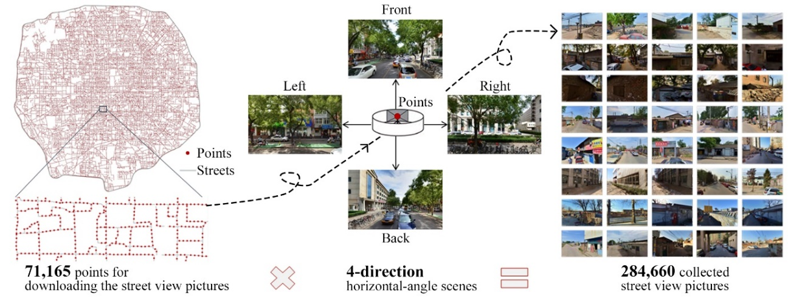
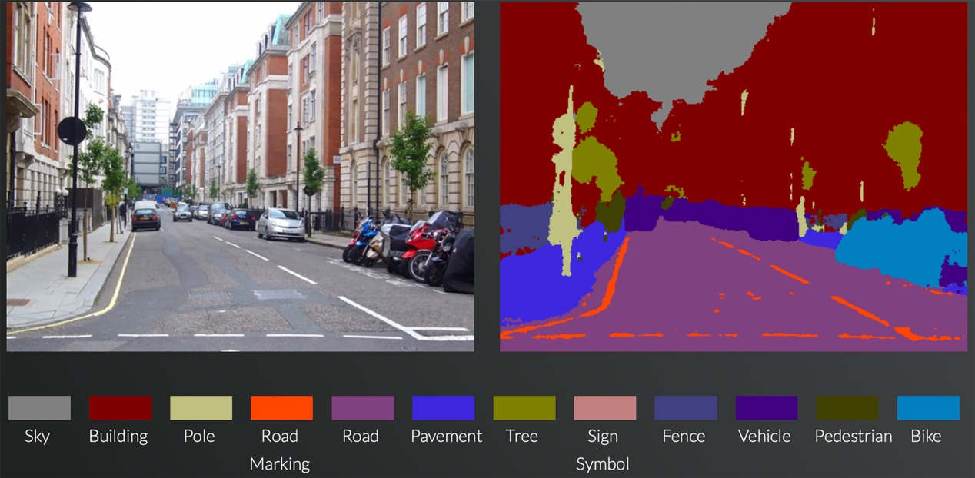
A segmentation demo by SegNet. (http://mi.eng.cam.ac.uk/projects/segnet/).
12 categories of street element proportions (including Sky, Building, Pole, Road Marking, Road, Pavement, Tree, Sign, Fence, Vehicle, Pedestrian, and Bike) can be calculated.

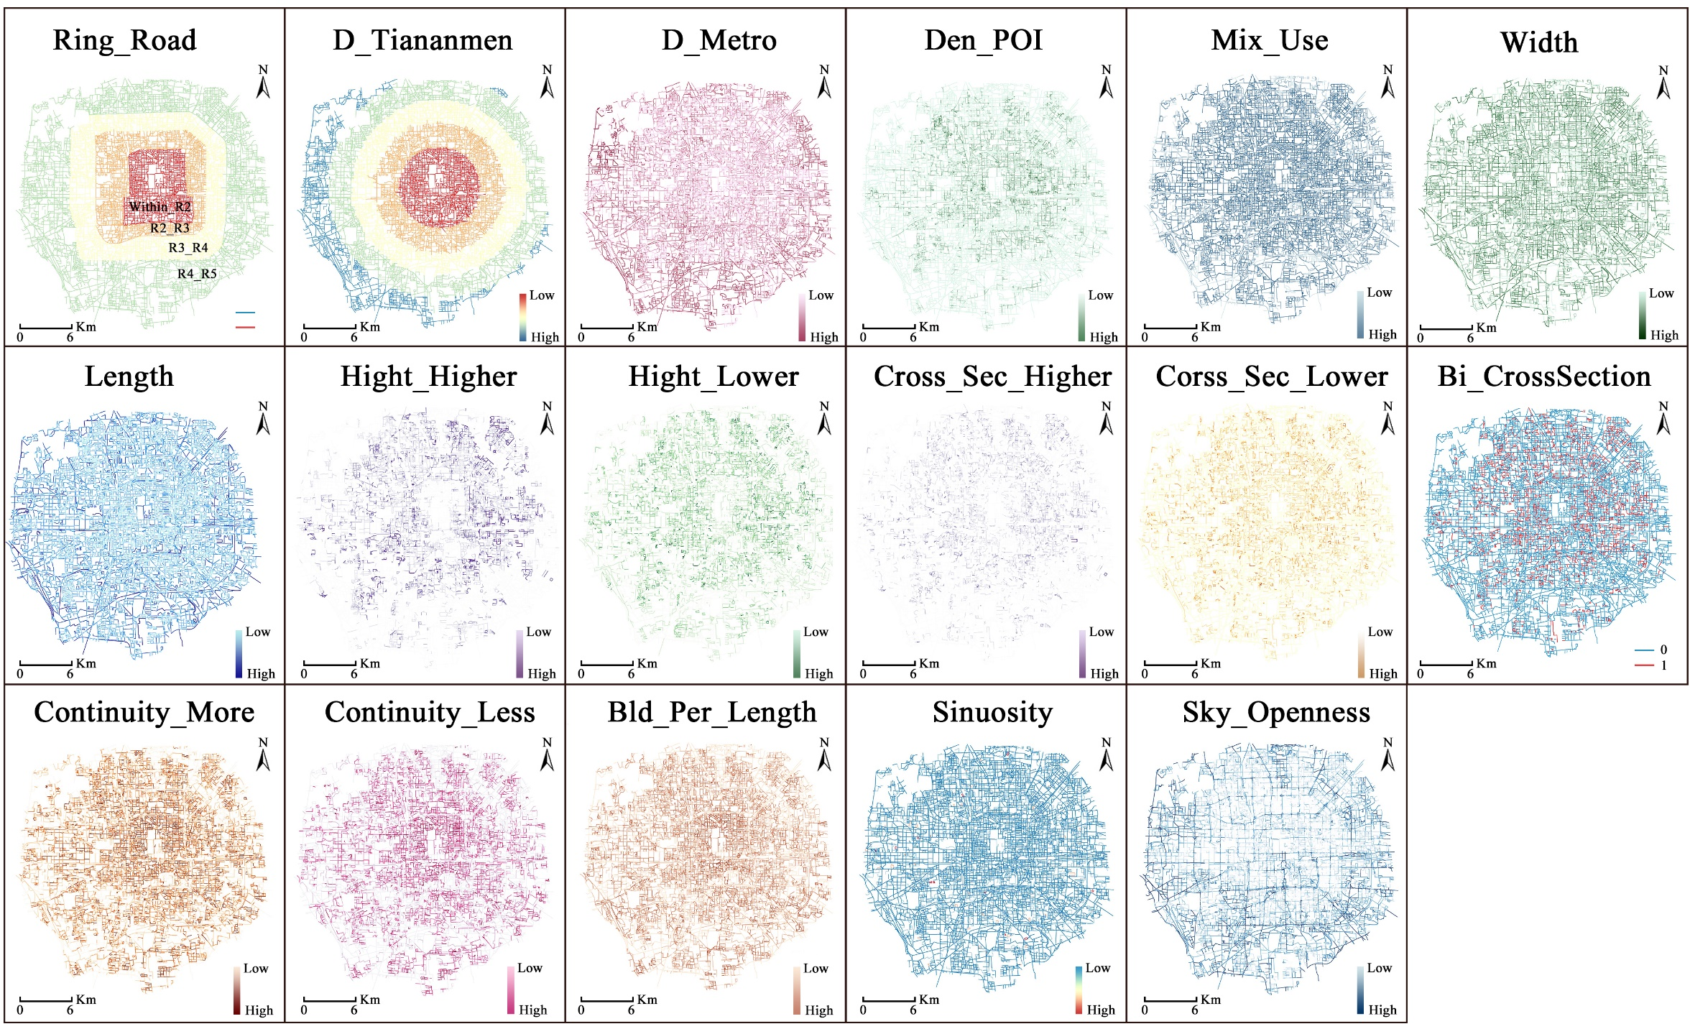
Figure S4. The spatial visualization of independent variables.

