20200303 Studio 3 Guomao - class5

General remarks
- Mid-term review on this Friday to present a whole story on the current progress
- Elements can include: site analysis based on data provided and past site visit, related case studies, future oriented lifestyle/city space/technologies, design strategy, general design (form, location, etc)
- Our studio topic: SHARING FUTURE CITY

Green public service: Gabriel Manuel Thomas Russell STELLA

- Understand the site condition better
- More on services: location, catchment/coverage, size of people serving, spatial form of service venue
- Better combine green infrastructure and public services
- Typology of connection between (green) nodes?
- Some green on map is not really accessible

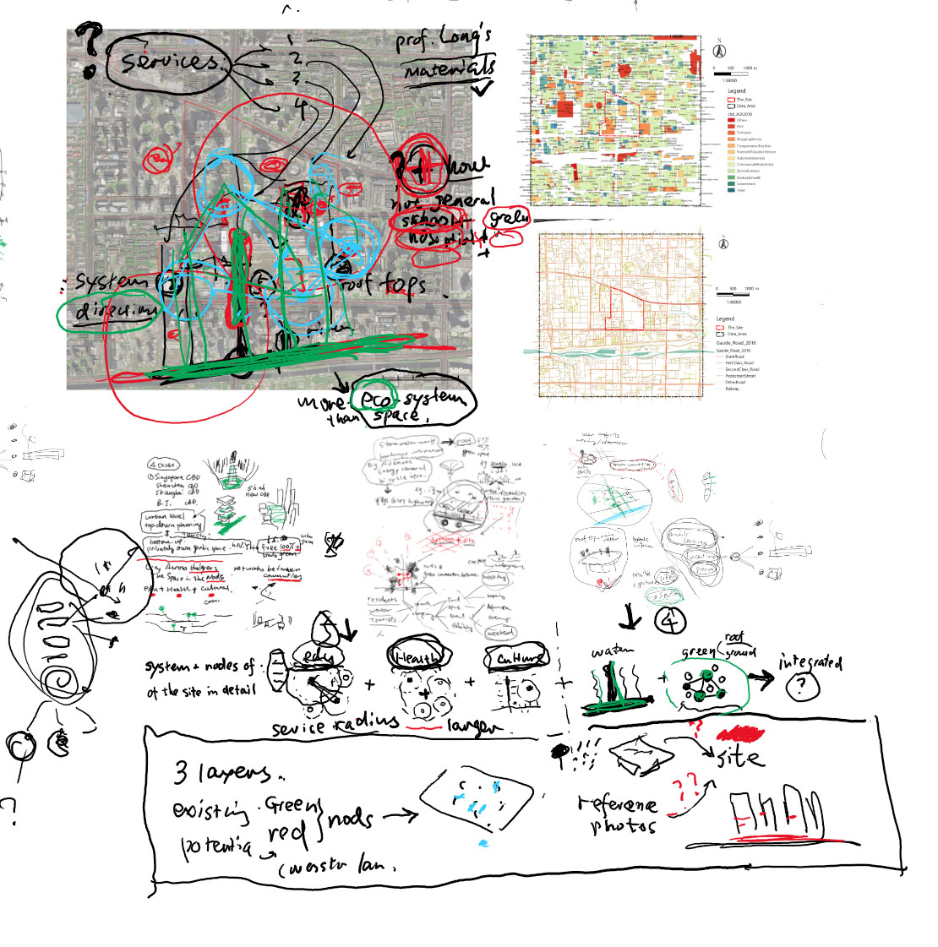

Work, Benny Minhui Prera Huiying

- Consider supporting system like gym, food/beverage, meeting room, cafeteria, etc for working
- Justify why connections in the current presenting way
- Justify the ratio change of different function
- Details of the site are necessary to understand like entrance/bus access etc
- Future work style for various temporal duration like 1 h, 1 d or 1 m, 1y and consider more on future work

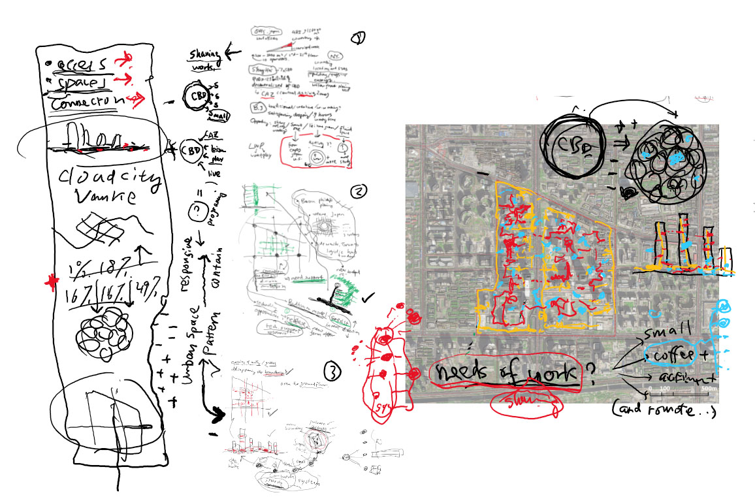

LIVING, Paul Natalia Mattia Rita

- More on real condition of living/housing of the site
- Strengthen the typology study of living units
- On the architectural level: the organization of units and related public space/facilities
- On the urban level: spatial strategies for new building design and for existing housing
- integrate the previous work together and to make the whole story complete
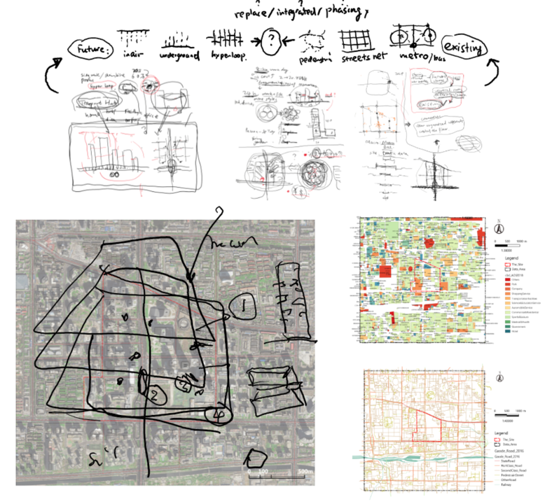

MOBILITY, Katherine Nathan Lala Tsunxian

- Consider public transportation and pedestrian environment
- Re-evaluate the current locations of hubs while referring existing and planned metro stations
- Details of hubs and nodes
- How to link the existing system with the new one? (Tree vs Net systems)
- How to connect hub to node, node to building in the design?
- Density of working in daytime is high, how to accommodate them in the design?

